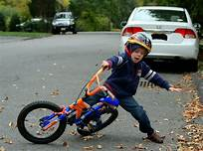
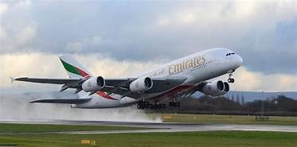
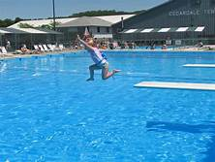
Name_________________________________ Date ______________________ Block_____________________
Writing Plot :The series of events in a story
_________________________  _____________________________  _____________________________  _____________________________  _____________________________  _____________________________ | _________________________  _____________________________  _____________________________  _____________________________  _____________________________  _____________________________ | _________________________  _____________________________  _____________________________  _____________________________  _____________________________  _____________________________ | _________________________  _____________________________  _____________________________  _____________________________  _____________________________  _____________________________

_________________________  _____________________________  _____________________________  _____________________________  _____________________________  _____________________________ | _________________________  _____________________________  _____________________________  _____________________________  _____________________________  _____________________________ | _________________________  _____________________________  _____________________________  _____________________________  _____________________________  _____________________________ | _________________________  _____________________________  _____________________________  _____________________________  _____________________________  _____________________________

